Frank Hertz Experiment

J. Hartsell and Michael Lane

Georgia Institute of Technology, School of Physics

(Dated: June 5, 2012)

1. **Background**

Just before the Era of World War I, physics had just begun to tackle the problem of quantization as observed in the Millikan oil drop, Mosley X-Ray Diffraction Experiment, and other experiments that probed the properties of the atom, atomic spectra and the Einstein would later define as the photoelectric effect. The Franck-Hertz experiment, rest conducted in 1914, is a historic experiment that showed quantized internal energy excitation in atoms. In fact, both Frank and Hertz would earn then Nobel peace prize for their work later. During his acceptance of this award, Dr. Frank remarked how, “It might interest you to know that when we made the experiments that we did not know Bohr's theory. But we did not know whether that would be so, and we did not know whether at all an emission of an atom is of such a type that one line alone can be emitted and all the energy can be used for that purpose. The experiment gave it to us, and we were surprised about it. But we were not surprised after we read Bohr's paper later, after our publication" (Magill, 1989) Though it would was an accident the support Franck Hertz’s experiment did for Bohr’s theory of the hydrogen atom in proving quantization, which would later allow the development a full quantum understanding of the atom using Planck’s constant (Kellogg & Brander Matthews Dramatic Museum Collection (Library of Congress), 1933).

1. **Procedure of Hg Photodiode tube:**

 In the Franck-Hertz experiment, electrons are accelerated by an electric held through a monatomic vapor, in this case Mercury and Helium. Over the years experiment has been refined taking into account modern kinetic theory of gases (Hanne, 1988; Robson, Li, & White, 2000). The electrons traveling through the vapor collide with the atoms. These collisions are completely elastic unless the electron has more energy than the rest excited state of the atom. In such an elastic collision, the energy transferred to the atom by the electron is found from basic no relativistic kinetics to be:

(1)

Here $K = Kinematic Energy$ while $m and M = the masses of the two colliding atoms.$ (This formula is not important other then in general passing remark for historical reasons.) When the energy of the incident electrons is greater than the energy necessary to excite the atom, inelastic collisions can take the atom to one of its low-lying excited states. The electron loses this energy. After the collision, subsequent acceleration of the electron may bring it once again into an energy regime where it can in elastically collide with the atoms in the vapor. To measure the energy of electrons after they have traveled some distance in the atomic vapor, an electric field that decelerates the electrons is introduced between grid and an anode ()

Figure : Pictures showing the Franck Hertz Experimental Setup and wiring including the Keithly 487 Picometer, various Aligent E3610 power supplies, a thermometer control, and a variac generator. To the right are pictures of the 3B Scienctific Mercury tube, the location of the collector plate in the tube, and the glowing fringes that occur with the tube reaches a peak accelerating voltage. Unfortunately the distance between the gate a collector is too small.

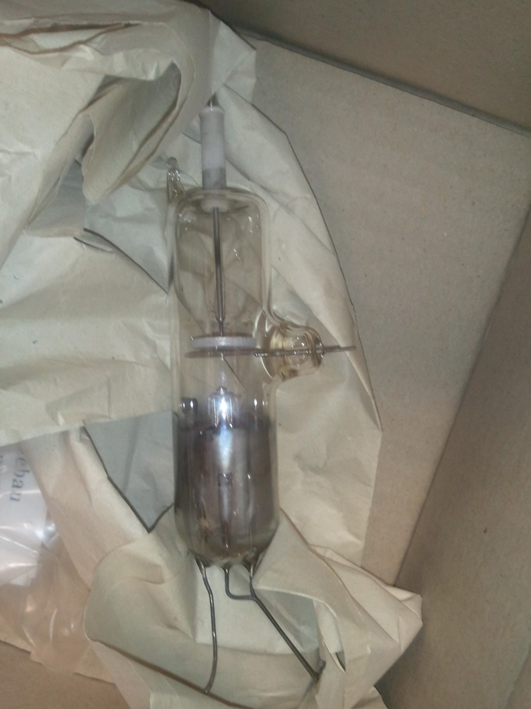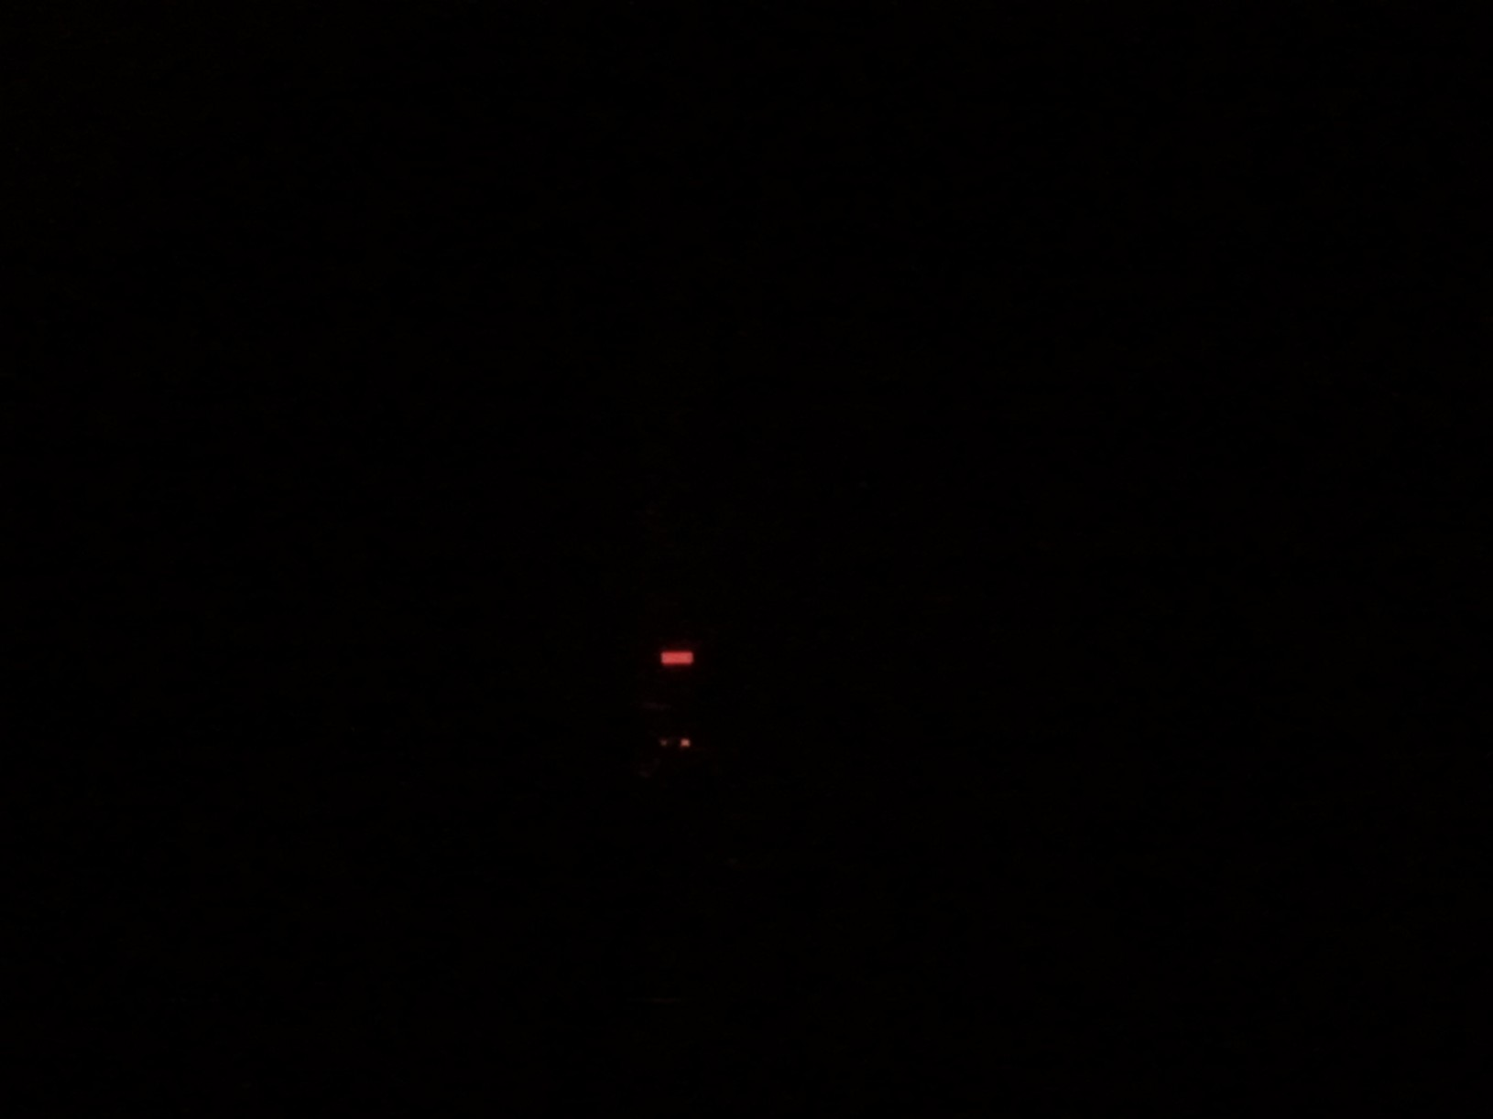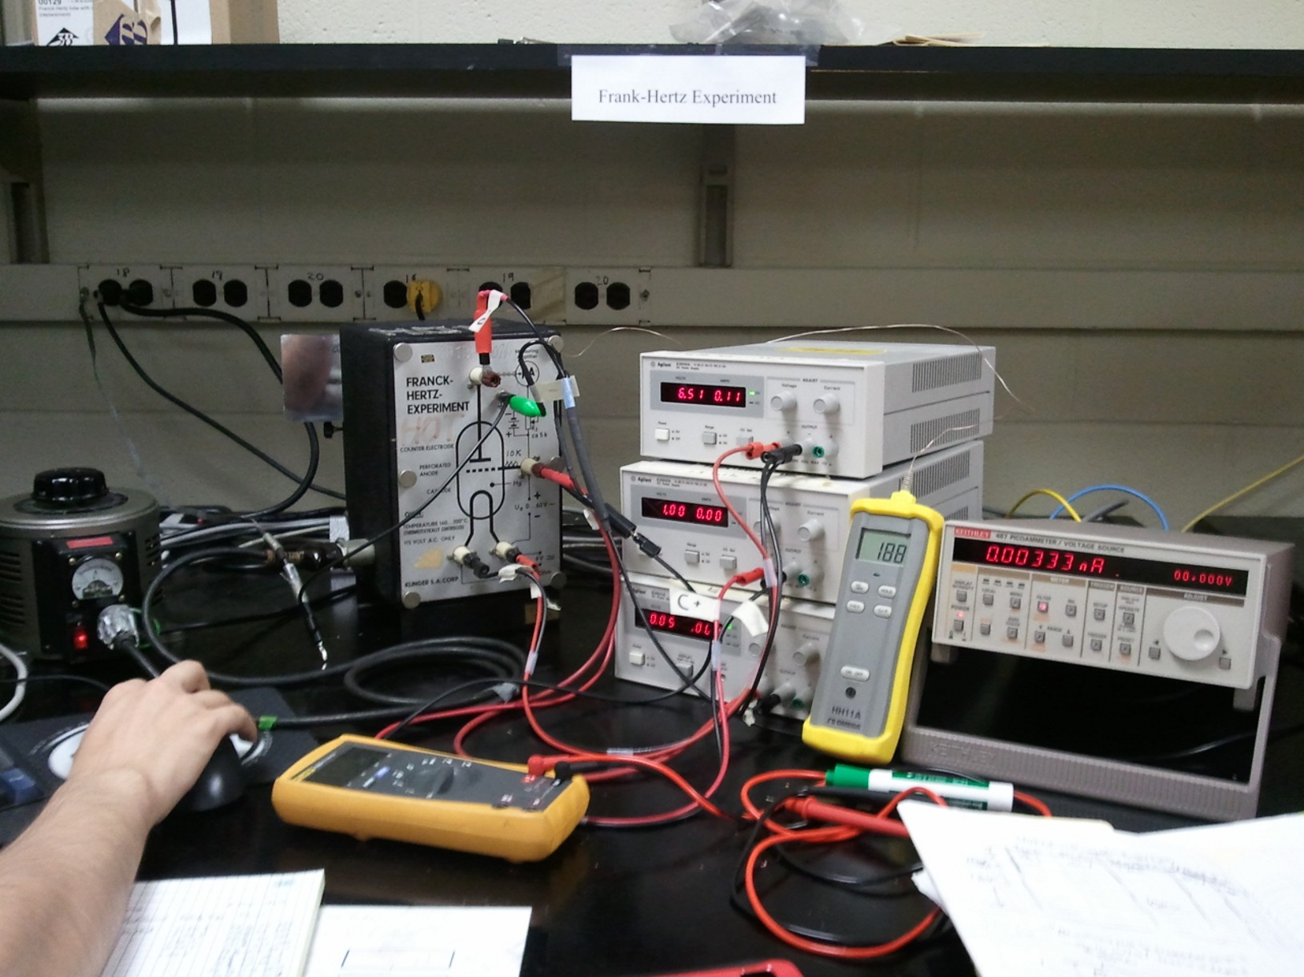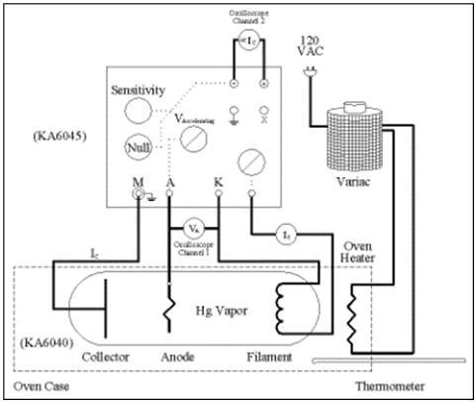

In order to conduct the experiment, we used a commercially available Franck- Hertz apparatus from the Klinger In this apparatus, both vapors vapor was heated to temperatures to 190 degrees C in a glass tube. Electrons liberated from a heated ﬁlament’s by means of an applied voltage, $V_{f}$, were accelerated through the both a mercury vapor and a neon vapor by an

The commercially available Franck-Hertz experiment apparatus contains a glass tube with a small quantity of liquid mercury is heated so that some of the mercury goes into the gas phase Electrons are liberated within this tube by a heated ﬁlament’s ($F$) and accelerated through the gas by an applied voltage ($Va$) between the cathode ($H$) and the grid ($G$). A retarding electric ﬁeld produced by another connection is applied between the grid and the anode collector ($A$). The resulting current ﬂow between the grid and collector ($I$) is measured by a precision Keithly 487 Picometer. The retarding and accelerating equipotential is chosen so that electrons with relatively high kinetic energies will pass between the grid and anode, resulting in a measureable current retardation between the anode and the grid. Less energetic electrons will pass through the grid and then return to it instead of reaching the anode. These electrons do not contribute to $I$. The physical picture presented is very idealistic. Researchers have pointed out that using this grid technique for measuring the current is intrusive and eﬀects the experimental results (Nicoletopoulos, 2008); however, for an introductory lab, I believe it suits the purpose well. For example, it ignores the elastic collisions, electron-atom interactions in the region of space between the grid and anode, and velocity distributions of atoms and electrons (Sigeneger, Winkler, & Robson, 2003).

Mercury was used for this experiment because its vapor is monatomic. Monatomic vapors are preferred over molecular gases such as hydrogen for this experiment. Molecular gases have closely-spaced ro-vibrational states that electively wash out the quantized states in the excitation spectrum. Furthermore, mercury’s vapor density is variable with temperature, an easily controlled experimental variable.

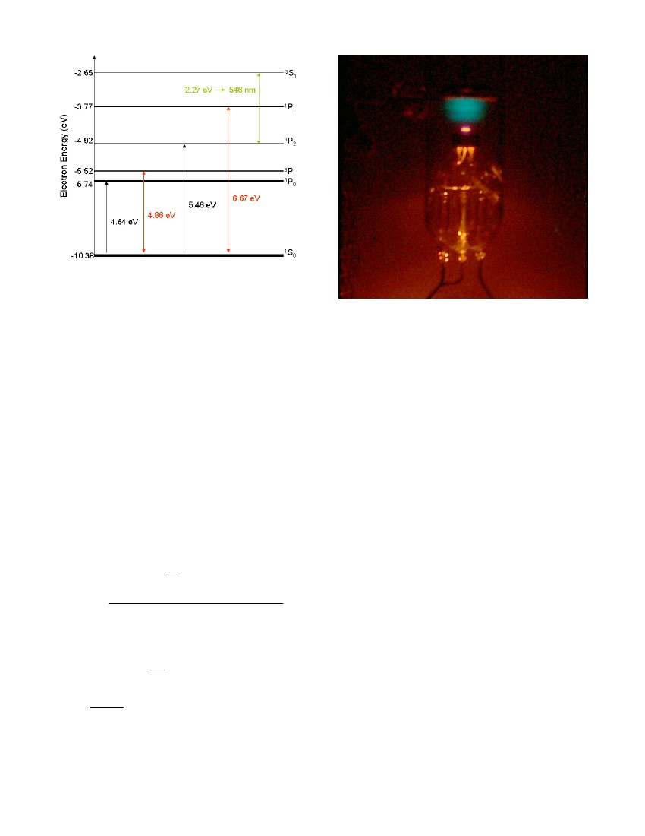

Figure 2: Spectrum of the Mercury atom. Based on (Ralchenko, Kramida, Reader, & Team, 2011)

The lowest lying states of mercury that can be accessed by inelastic collisions are the transitions from the 1 S0, speed of light, e is the charge of an electron and V0 is the excitation potential for the 1 S0 →3 P1 transition. It is the acceleration electrons up to and discharges between these states that causes the voltage and amplitude to form like in Figure 1. Because some states are quashed, Frank and Hertz found that the maximum of the voltages could be plotted vs. an arbitrary number n. Then, by taking the slope of the plot, they get a change in the energy between states. It turns out that in the setup above, that change in energy is the ground state of the atom from its ionization state as zero.

1. **Results Mercury:**

For the conducted experiment, we measured the periodicity of the electron energy at the grid as follows for mercury and later Helium ()

. 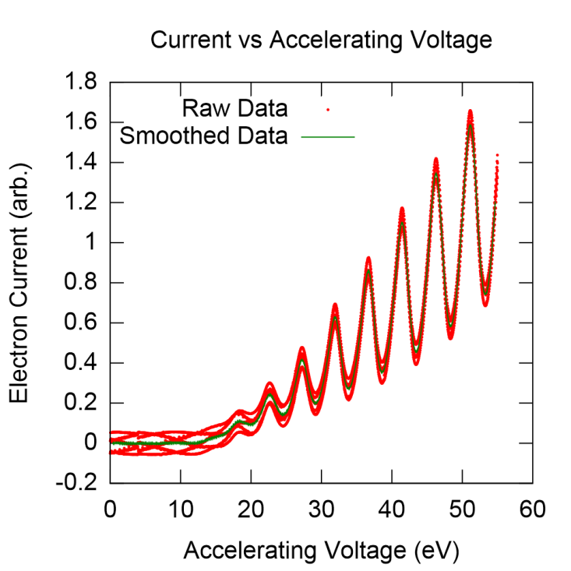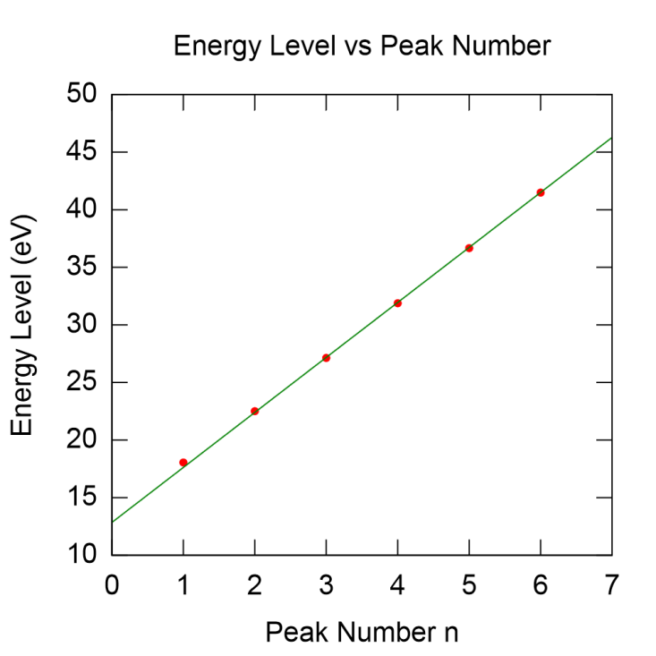

Figure 3 : A) (Left) Example Plot of Measured Hg Tube collector current vs. accelerating voltage (in eV). The right picture is the plot to find the first excited state of Mercury.

Initially, my partner and I had a little difficulty measuring the Franck Hertz data. As you can see from , there was a little bit of noise in the measure signal from Keithly 487 Picometer; moreover this noise, appears to be AC Offset Error cause by a 60, 64, or 120 Hz ground loop signal from the laboratory’s power lines. After close examination of the Lab Manual of the Klinger KA6060 Tube as well as conversations with Dr. First, we concluded that this noise was most likely due whereever the tube collector (the plate in is Figure 1). We solved this by applying a smoothing function of a running average, and thus used the green curve shown above to find the maximums, which the red data shows the margin of error in doing such a running average.

Using Gnuplot, anode current Iag was recorded while Vacc was increased from 0.0 to 45.0V in increments of 0.05V. Each ﬁle was the analyzed using Microsoft Excel 2003 where we fitted both the Mercury data to lines. Electrons that reached the anode were registered as negative current. Because electrons were decelerated between the grid and anode, this current is a measure of the electron. The excitation potential was measured to be 4.76 ± 0.04 eV. This value agrees with the expected value of 4.86 eV of the ground state 1 S0 →3 P1 transition. Overall, it still shows the quantization of atoms to the fact that the Maximum accelerating voltages are actually incrementally increasing by the same factor or packet of energy, which are called quanta.

1. **Procedure for Helium Spectrum**

Figure 4: Experimental Setup for the Helium Experiment

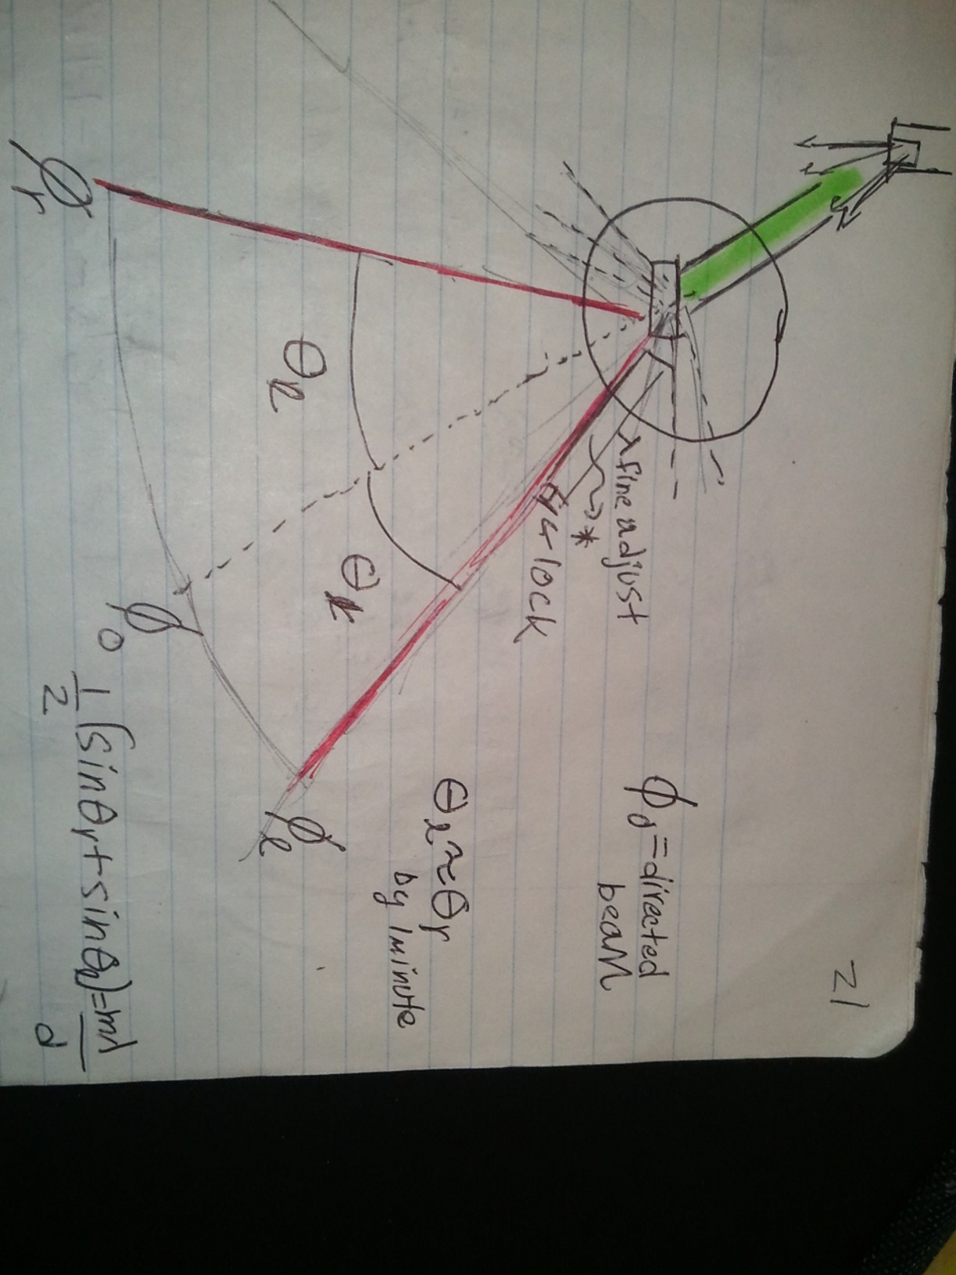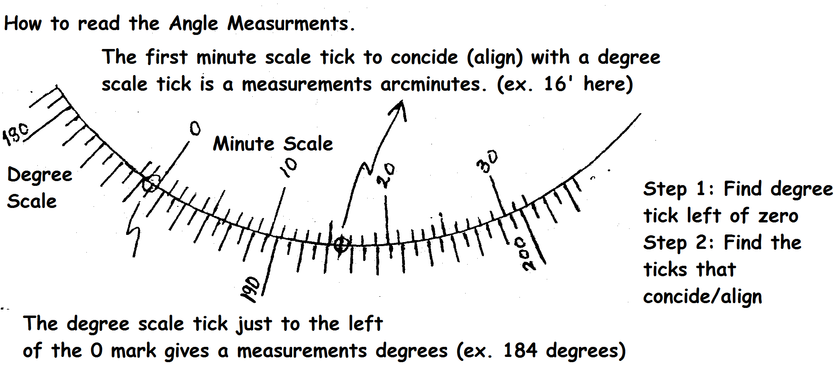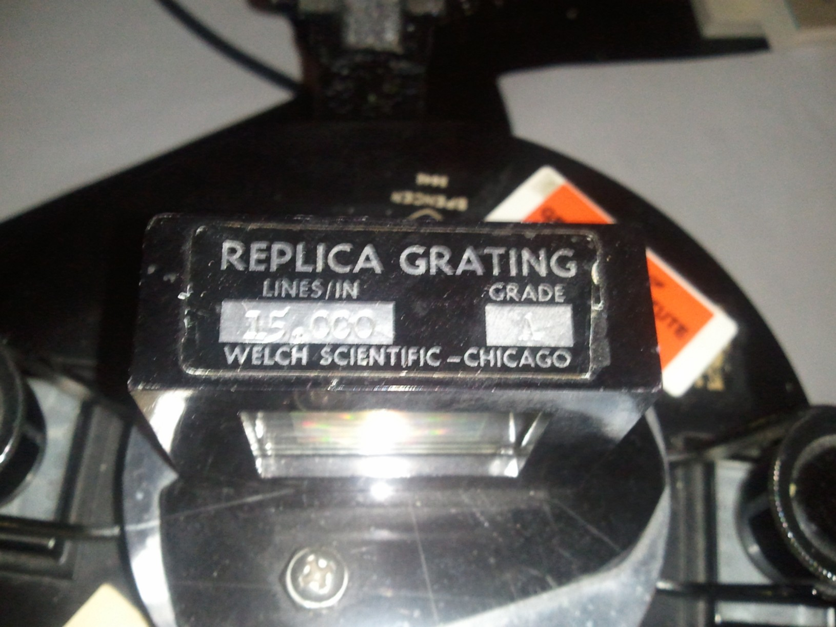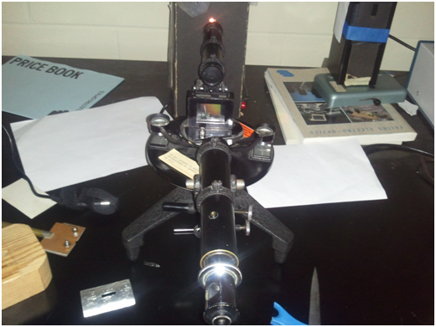

Lamp

**Cenco Na**

**Vapor Lamp**

**Spencer 3642**

**AO Spectrometer**

$${θ_{r}=ϕ}_{r}{-ϕ}_{0}$$

$${θ_{l}=ϕ}_{l}{-ϕ}_{0}$$

Spencer

Spectrometer

Spectrometer

$$ϕ_{0}=directed beam$$

$$θ_{r}=right angle$$

$$θ_{l}=left angle$$

$$ϕ_{l}=right postion$$

$$ϕ_{l}=left postion$$

Beyond the simple measurement of the Photodiode’s electrical potential change, Frank and Hertz observed that they could actually take the lamp and measure its spectrum using a spectrograph diffraction grating device (see ). We measure the wavelength by taking the differences in the angles of left and right the line we observe is from center.

1. **Results for Helium**

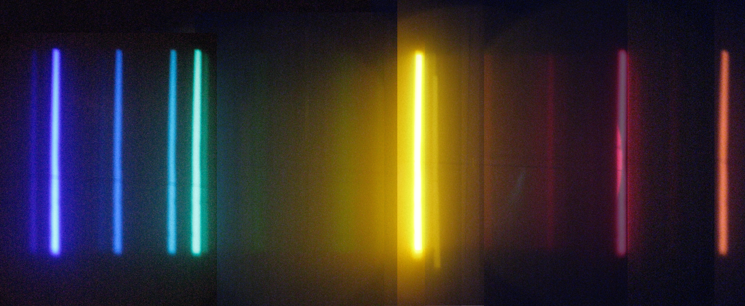

**4485Å 4724 Å 5035 Å 5884 Å 6745 Å 7073 Å**

**4924 Å**

Figure 4 above is a picture of the spectral lines observed for Helium

(2) 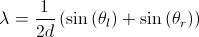

Overall I got very good result for Helium. After finding the angles, I used the formula above to calculate . The following table below summarizes the results. I found that by taking the difference in the states in He and comparing them to the differences in the energy levels of He that each of the peak corresponded to a different P – S3 transition for the He I. Using the data values I got an average Plank’s constant of roughly 6.6E -34 Js which while not as good as I hoped was pretty close and we are. I am not sure where the data came from so I am not sure of the error. When I looked that $λ$-values for He I, I found that they instead corresponded to the Balmier series transitions to the P-shell orbital’s but not the same transitions as for the graphical data. To calibrate the He I spectrum I had to use Sodium Lamp. The Sodium had the interesting property that the I observed a double lines for sodium at expected 5889.95 and 5895.92 Å wavelengths. These double lines are caused by coupling of the orbital momentum and spin of the atoms. orbital angular moment of the outermost electron.

Table 1 Observed Values for Helium

 

Table 2 Calculating Planck's constant using Helium



1. **Appendix of Tables**

**Table 3: Measured Energy Levels of Helium**



Table 4: Measure Hg Levels



Table 5: Color Coated He Spectrum Lines



Table 6 Na Spectrum Lines



1. References

Hanne, G. F. (1988). What Really Happens in the Franck-Hertz Experiment with Mercury. *American Journal of Physics, 56*(8), 696-700.

Kellogg, F. B., & Brander Matthews Dramatic Museum Collection (Library of Congress). (1933). [Speech given at dinner in honor of Alfred Nobel] [sound recording .].

Magill, F. N. (1989). *The Nobel Prize winners. Physics*. Pasadena, Calif.: Salem Press.

Nicoletopoulos, P. (2008). Double-layer formation in the extended Franck-Hertz experiment. *Physical Review E, 78*(2). doi: Artn 026403

Robson, R. E., Li, B., & White, R. D. (2000). Spatially periodic structures in electron swarms and the Franck-Hertz experiment. *Journal of Physics B-Atomic Molecular and Optical Physics, 33*(3), 507-520.

Sigeneger, F., Winkler, R., & Robson, R. E. (2003). What really happens with the electron gas in the famous Franck-Hertz experiment? *Contributions to Plasma Physics, 43*(3-4), 178-197. doi: DOI 10.1002/ctpp.200310014